Unit 3

Task 1: Data structure 3_Tree & Graph_Chapter 1
Program 1 :
import java.util.*;

class Node {
int data;
Node left, right;
Node(int d) { data = d; }
}

public class Main {

static Node insert(Node root, int val) {
if (root == null)
return new Node(val);

if (val < root.data)
root.left = insert(root.left, val);
else
root.right = insert(root.right, val);

return root;
}

static void inorder(Node root) {
if (root != null) {
inorder(root.left);
System.out.print(root.data + " ");
inorder(root.right);
}
}

public static void main(String[] args) {
Scanner sc = new Scanner(System.in);
Node root = null;

while (true) {
int n = sc.nextInt();
if (n == -1)
break;
root = insert(root, n);
}

inorder(root);
}
}
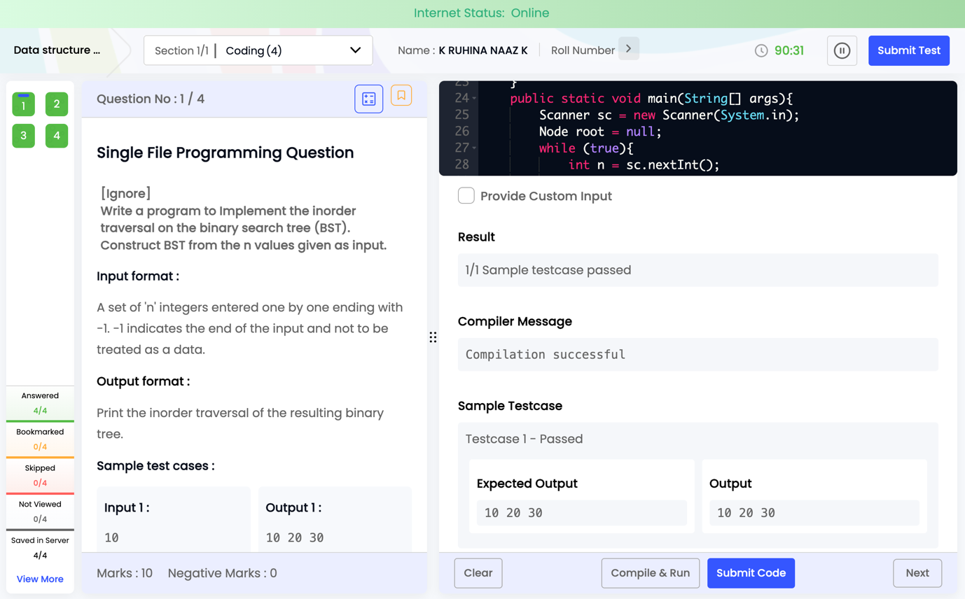

Program 2 :
import java.util.*;

class Node {
int data;
Node left, right;
Node(int d) { data = d; }
}

public class Main {

static Node insert(Node root, int val) {
if (root == null)
return new Node(val);

if (val < root.data)
root.left = insert(root.left, val);
else
root.right = insert(root.right, val);

return root;
}

static void inorder(Node root) {
if (root != null) {
inorder(root.left);
System.out.print(root.data);
if(root.right != null) System.out.print(" ");
inorder(root.right);
}
}

static void preorder(Node root) {
if (root != null) {
System.out.print(root.data);
if(root.left != null || root.right != null) System.out.print(" ");
preorder(root.left);
preorder(root.right);
}
}

static void postorder(Node root) {
if (root != null) {
postorder(root.left);
postorder(root.right);
System.out.print(root.data);
if(root != firstPost) System.out.print(" ");
}
}

static Node firstPost; // helper for space handling

public static void main(String[] args) {
Scanner sc = new Scanner(System.in);
Node root = null;

while (true) {
int n = sc.nextInt();
if (n == -1)
break;
root = insert(root, n);
}

inorder(root);
System.out.println();
preorder(root);
System.out.println();

firstPost = root;
postorder(root);
}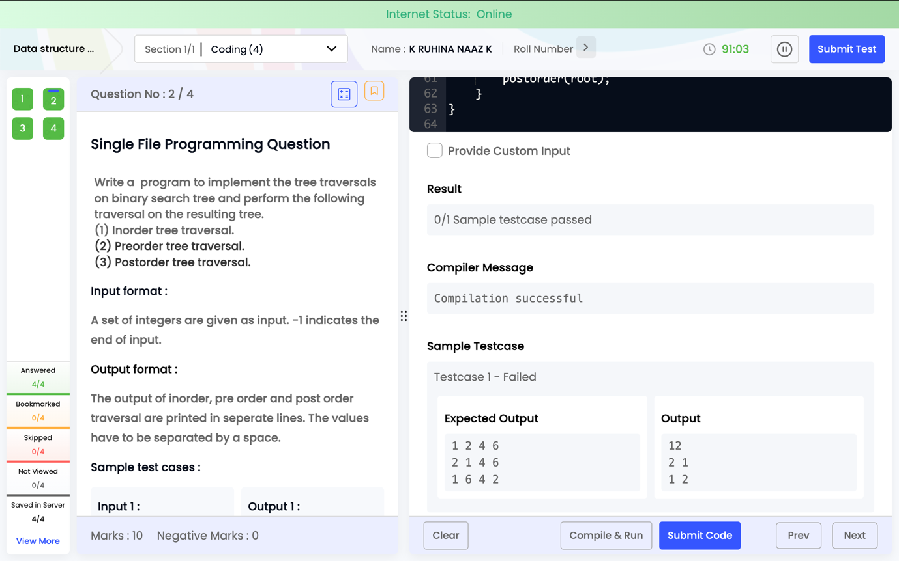

Program 3 :
import java.util.*;

class Node {
int data;
Node left, right;
Node(int d) { data = d; }
}

public class Main {

static Node root = null;

static boolean insert(int val) {
if (root == null) {
root = new Node(val);
return true;
}

Node curr = root;
while (true) {
if (val == curr.data)
return false; // duplicate

if (val < curr.data) {
if (curr.left == null) {
curr.left = new Node(val);
return true;
}
curr = curr.left;
} else {
if (curr.right == null) {
curr.right = new Node(val);
return true;
}
curr = curr.right;
}
}
}

public static void main(String[] args) {
Scanner sc = new Scanner(System.in);
boolean success = true;

while (true) {
int n = sc.nextInt();
if (n == -1)
break;

if (!insert(n))
success = false;
}

if (success)
System.out.print("Success");
else
System.out.print("Failure");
}
}

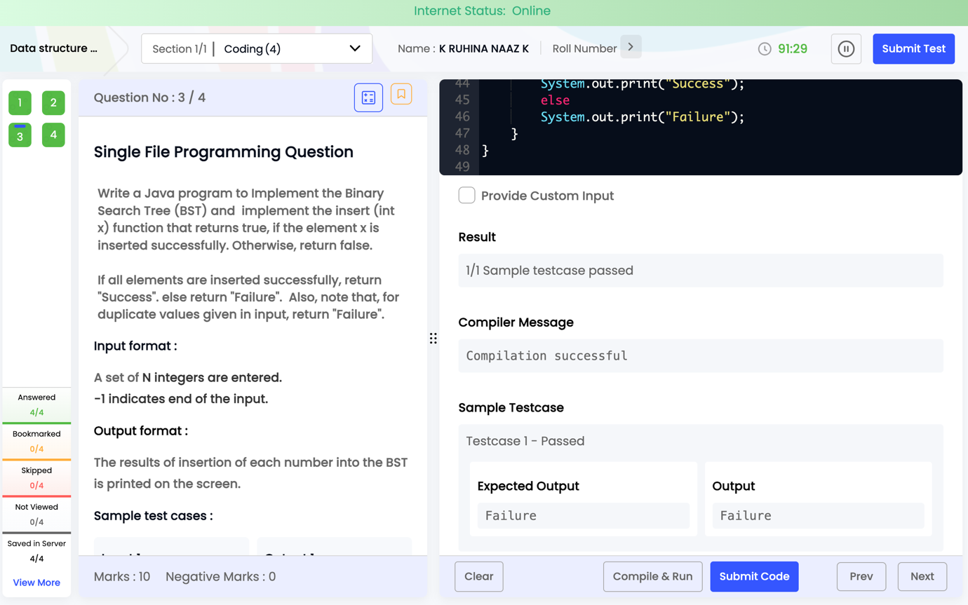

Program 4 :
import java.util.*;

class Node {
int data;
Node left, right;
Node(int d) { data = d; }
}

public class Main {

static Node root = null;

static void insert(int val) {
if (root == null) {
root = new Node(val);
return;
}

Node curr = root;
while (true) {
if (val < curr.data) {
if (curr.left == null) {
curr.left = new Node(val);
return;
}
curr = curr.left;
} else {
if (curr.right == null) {
curr.right = new Node(val);
return;
}
curr = curr.right;
}
}
}

static boolean search(int x) {
Node curr = root;
while (curr != null) {
if (x == curr.data)
return true;
else if (x < curr.data)
curr = curr.left;
else
curr = curr.right;
}
return false;
}

public static void main(String[] args) {
Scanner sc = new Scanner(System.in);

// Insert values
while (true) {
int n = sc.nextInt();
if (n == -1)
break;
insert(n);
}

// Search value
int x = sc.nextInt();

if (search(x))
System.out.print(x + " is Found");
else
System.out.print(x + " is Not Found");
}
}

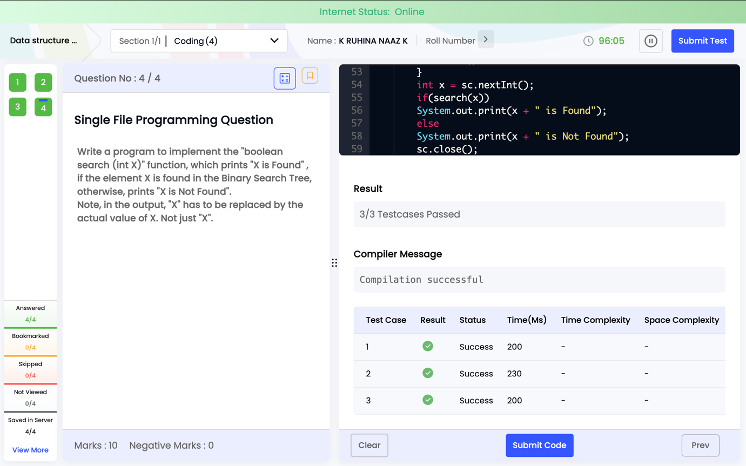

Task 2 : Data structure 3_Tree & Graph_Chapter 2
Program 1 :
import java.util.*;

class Main {
static class Node {
int data;
Node left, right;
Node(int d) { data = d; }
}

static Node root;

static Node insert(Node r, int d) {
if (r == null) return new Node(d);
if (d < r.data) r.left = insert(r.left, d);
else if (d > r.data) r.right = insert(r.right, d);
return r;
}

static Node min(Node r) {
while (r.left != null) r = r.left;
return r;
}

static Node deleteNode(Node r, int x, boolean[] f) {
if (r == null) return null;

if (x < r.data) r.left = deleteNode(r.left, x, f);
else if (x > r.data) r.right = deleteNode(r.right, x, f);
else {
f[0] = true;
if (r.left == null) return r.right;
if (r.right == null) return r.left;

Node t = min(r.right);
r.data = t.data;
r.right = deleteNode(r.right, t.data, f);
}
return r;
}

static boolean delete(int x) {
boolean[] f = new boolean[1];
root = deleteNode(root, x, f);
return f[0];
}

public static void main(String[] args) {
Scanner sc = new Scanner(System.in);

int n;
while ((n = sc.nextInt()) != -1)
root = insert(root, n);

int x = sc.nextInt();
System.out.println(delete(x) ? "True" : "False");
}
}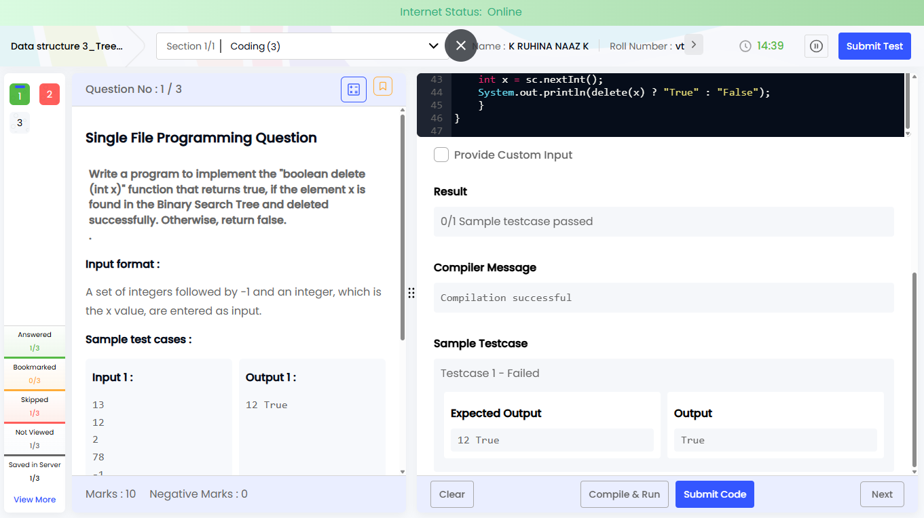
Program 2 :
import java.util.*;

class Main {
public static void main(String[] args) {
Scanner sc = new Scanner(System.in);

int V = sc.nextInt();
int E = sc.nextInt();

List<List<Integer>> adj = new ArrayList<>();

for (int i = 0; i < V; i++)
adj.add(new ArrayList<>());

// Read edges
for (int i = 0; i < E; i++) {
int u = sc.nextInt();
int v = sc.nextInt();
adj.get(u).add(v);
adj.get(v).add(u); // undirected graph
}

int start = sc.nextInt();

boolean[] visited = new boolean[V];
Queue<Integer> q = new LinkedList<>();

q.add(start);
visited[start] = true;

System.out.println("BFS Traversal:");

while (!q.isEmpty()) {
int node = q.poll();
System.out.print(node + " ");

for (int nei : adj.get(node)) {
if (!visited[nei]) {
visited[nei] = true;
q.add(nei);
}
}
}
}
}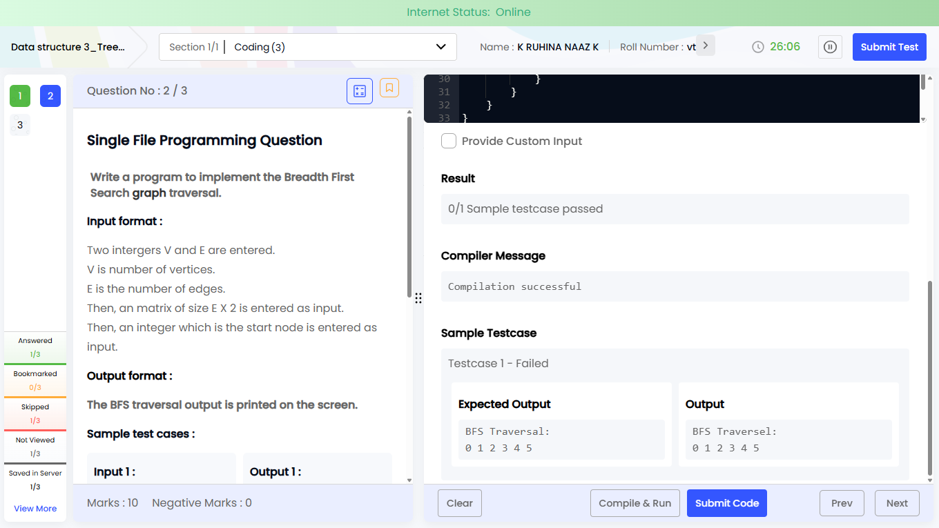

Program 3:
import java.util.*;

class Main {
static void dfs(int node, boolean[] visited, List<List<Integer>> adj) {
visited[node] = true;
System.out.print(node + " ");

for (int nei : adj.get(node)) {
if (!visited[nei])
dfs(nei, visited, adj);
}
}

public static void main(String[] args) {
Scanner sc = new Scanner(System.in);

int V = sc.nextInt();
int E = sc.nextInt();

List<List<Integer>> adj = new ArrayList<>();

for (int i = 0; i < V; i++)
adj.add(new ArrayList<>());

// Read edges
for (int i = 0; i < E; i++) {
int u = sc.nextInt();
int v = sc.nextInt();
adj.get(u).add(v);
adj.get(v).add(u); // undirected graph
}

int start = sc.nextInt();

boolean[] visited = new boolean[V];

System.out.println("DFS Traversal:");
dfs(start, visited, adj);
}
}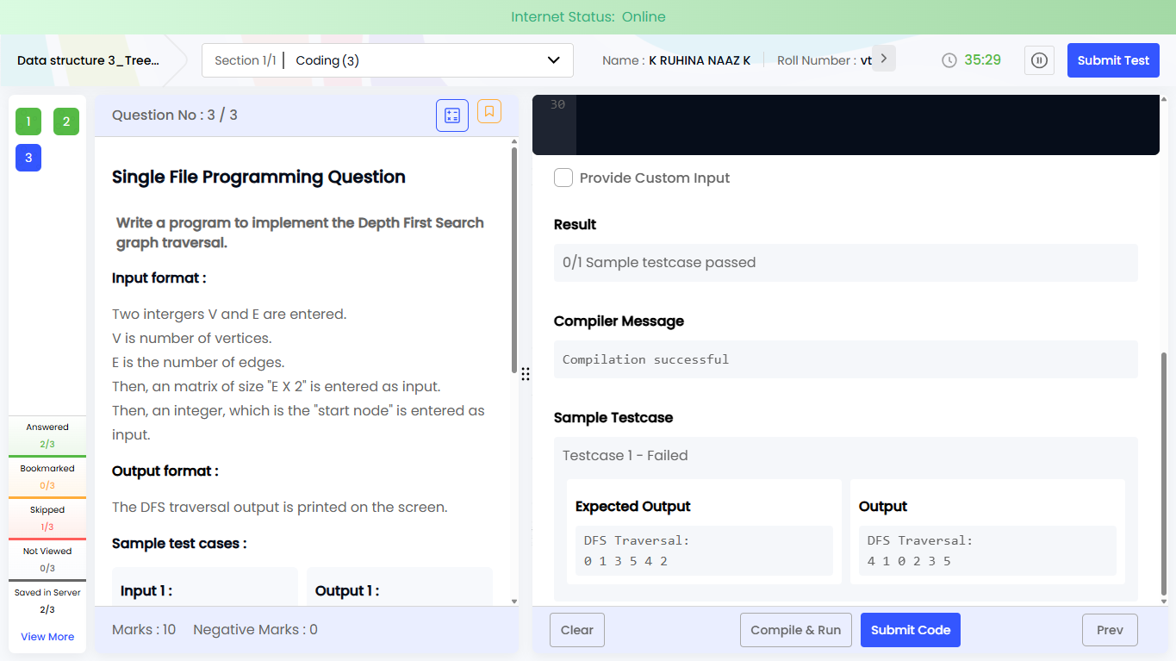

Task 3 : PREP_DSA_PT_Tree_1
Program 1:
import java.util.*;

class Node{
int data;
Node left,right;
Node(int d){ data=d; }
}

public class Main{

static Node insert(Node root,int val){
if(root==null) return new Node(val);
if(val<root.data) root.left=insert(root.left,val);
else root.right=insert(root.right,val);
return root;
}

static void post(Node root){
if(root==null) return;
post(root.left);
post(root.right);
System.out.print(root.data+" ");
}

public static void main(String[] args){
Scanner sc=new Scanner(System.in);
int n=sc.nextInt();
if(n<=0){
System.out.print("-1");
return;
}

Node root=null;
for(int i=0;i<n;i++){
root=insert(root,sc.nextInt());
}

post(root);
}
}
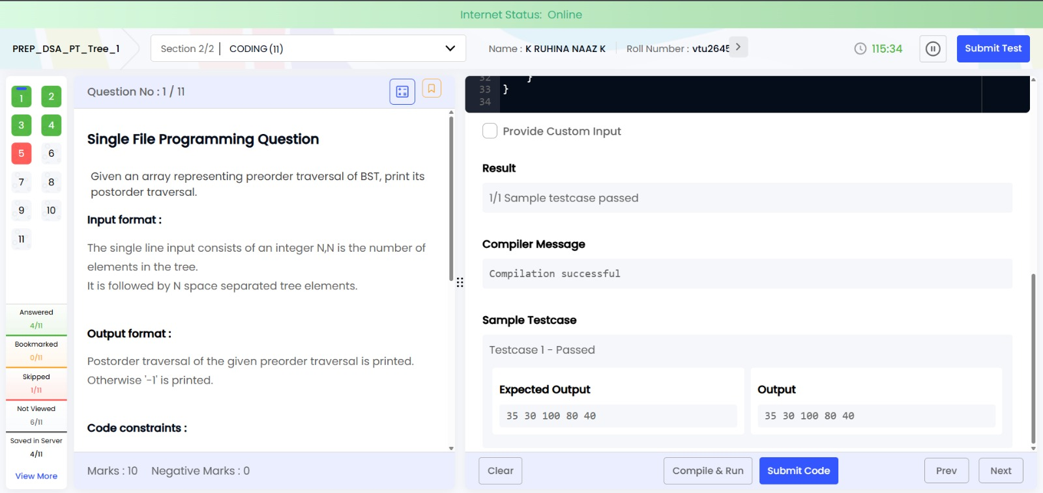

Program 2:
import java.util.*;

class Node{
char data;
Node left,right;
Node(char d){data=d;}
}

public class Main{

static Node insert(Node r,char c){
if(r==null) return new Node(c);
if(Character.toLowerCase(c) < Character.toLowerCase(r.data))
r.left=insert(r.left,c);
else
r.right=insert(r.right,c);
return r;
}

static void ascUpper(Node r){
if(r==null) return;
ascUpper(r.left);
if(Character.isUpperCase(r.data))
System.out.print(r.data);
ascUpper(r.right);
}

static void descLower(Node r){
if(r==null) return;
descLower(r.right);
if(Character.isLowerCase(r.data))
System.out.print(r.data);
descLower(r.left);
}

public static void main(String[] args){
Scanner sc=new Scanner(System.in);
int n=sc.nextInt();
Node root=null;

for(int i=0;i<n;i++){
char c=sc.next().charAt(0);
root=insert(root,c);
}

ascUpper(root);
System.out.println();
descLower(root);
}
}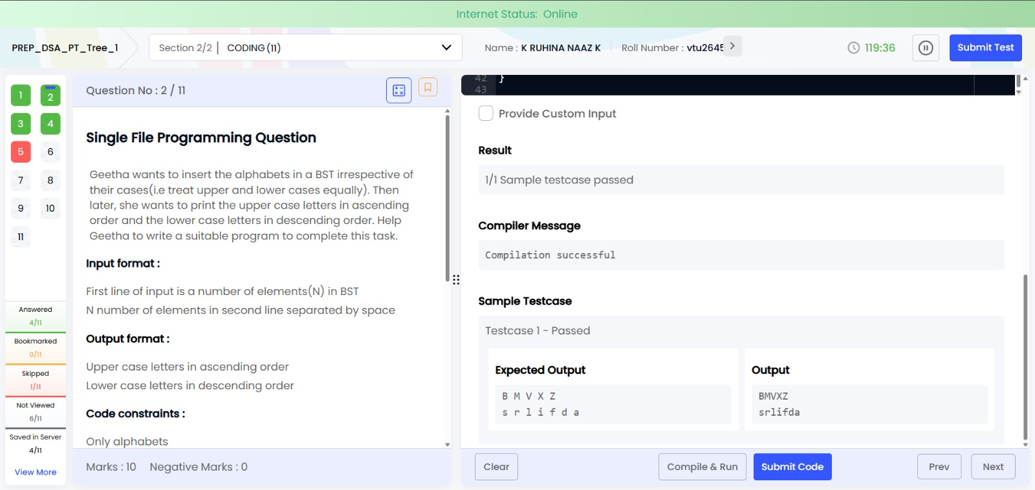

Program 3 :
import java.util.*;

class Node{
int d,h=1;
Node l,r;
Node(int d){this.d=d;}
}

public class Main{
static int h(Node n){ return n==null?0:n.h; }

static Node right(Node y){
Node x=y.l; y.l=x.r; x.r=y;
y.h=Math.max(h(y.l),h(y.r))+1;
x.h=Math.max(h(x.l),h(x.r))+1;
return x;
}

static Node left(Node x){
Node y=x.r; x.r=y.l; y.l=x;
x.h=Math.max(h(x.l),h(x.r))+1;
y.h=Math.max(h(y.l),h(y.r))+1;
return y;
}

static Node insert(Node n,int k){
if(n==null) return new Node(k);
if(k<n.d) n.l=insert(n.l,k);
else n.r=insert(n.r,k);

n.h=Math.max(h(n.l),h(n.r))+1;
int b=h(n.l)-h(n.r);

if(b>1 && k<n.l.d) return right(n);
if(b<-1 && k>n.r.d) return left(n);
if(b>1){ n.l=left(n.l); return right(n);}
if(b<-1){ n.r=right(n.r); return left(n);}
return n;
}

static void pre(Node n){
if(n!=null){
System.out.print(n.d+" ");
pre(n.l); pre(n.r);
}
}

public static void main(String[] args){
Scanner sc=new Scanner(System.in);
Node r=null;
for(int i=0;i<6;i++) r=insert(r,sc.nextInt());
pre(r);
}
}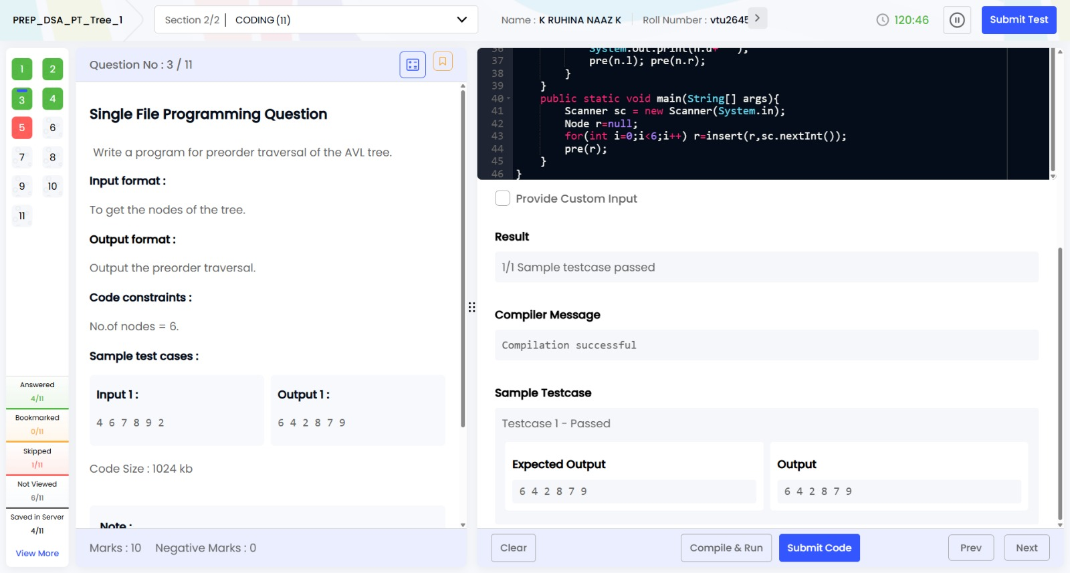

Program 4:
import java.util.*;

class Node{
int data;
Node left,right;
Node(int d){data=d;}
}

public class Main{

static Node insert(Node r,int x){
if(r==null) return new Node(x);
if(x<r.data) r.left=insert(r.left,x);
else r.right=insert(r.right,x);
return r;
}

static int size(Node r){
if(r==null) return 0;
return 1 + size(r.left) + size(r.right);
}

public static void main(String[] args){
Scanner sc=new Scanner(System.in);
Node root=null;

for(int i=0;i<5;i++)
root=insert(root,sc.nextInt());

System.out.print(size(root));
}
}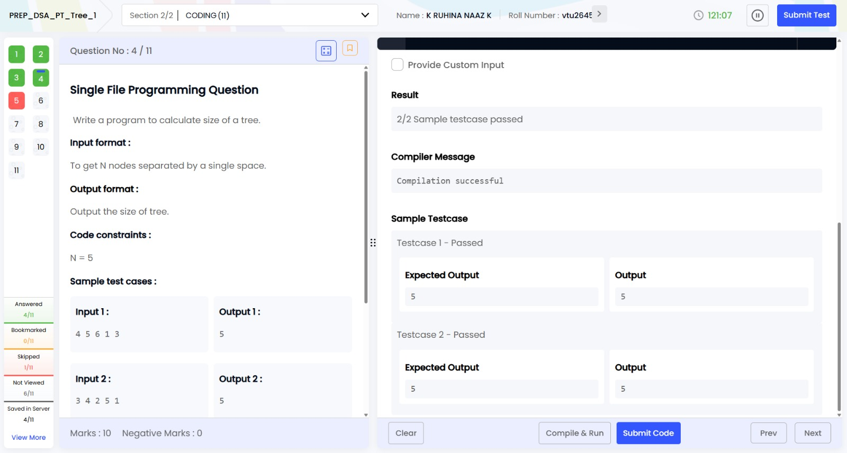

Program 5 :
import java.util.*;

class Node {
int data;
Node left, right;

Node(int d) {
data = d;
left = right = null;
}
}

public class Main {

static Node prev = null;
static Node head = null;

static void convert(Node root) {
if (root == null)
return;

convert(root.left);

if (prev == null)
head = root;
else {
root.left = prev;
prev.right = root;
}

prev = root;

convert(root.right);
}

static void printList(Node node) {
while (node != null) {
System.out.print(node.data + " ");
node = node.right;
}
}

static Node insert(Node root, int data) {
if (root == null)
return new Node(data);

if (data < root.data)
root.left = insert(root.left, data);
else
root.right = insert(root.right, data);

return root;
}

public static void main(String[] args) {
Scanner sc = new Scanner(System.in);

Node root = null;

for (int i = 0; i < 6; i++) {
int x = sc.nextInt();
root = insert(root, x);
}

convert(root);
printList(head);
}
}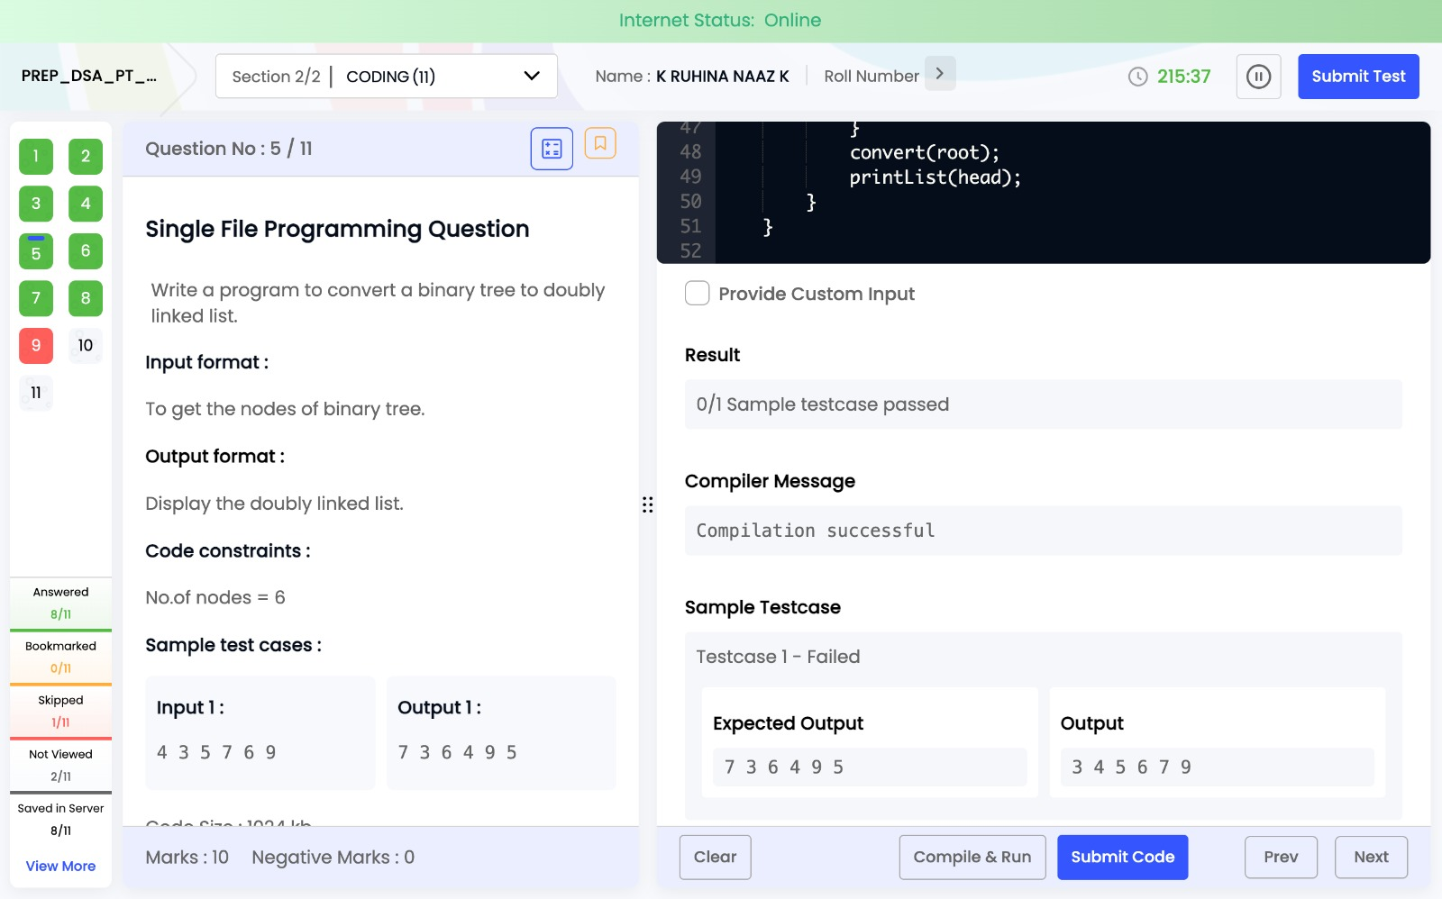

Program 6:
import java.util.*;

class Node{
int data;
Node left,right;

Node(int d){
data=d;
left=right=null;
}
}

public class Main{

static Node insert(Node root,int data){
if(root==null)
return new Node(data);

if(data<root.data)
root.left=insert(root.left,data);
else
root.right=insert(root.right,data);

return root;
}

static void inorder(Node root){
if(root!=null){
inorder(root.left);
System.out.print(root.data+" ");
inorder(root.right);
}
}

public static void main(String[] args){
Scanner sc=new Scanner(System.in);

int n=sc.nextInt();
Node root=null;

for(int i=0;i<n;i++){
int x=sc.nextInt();
root=insert(root,x);
}

System.out.print("INORDER ");
inorder(root);
}
}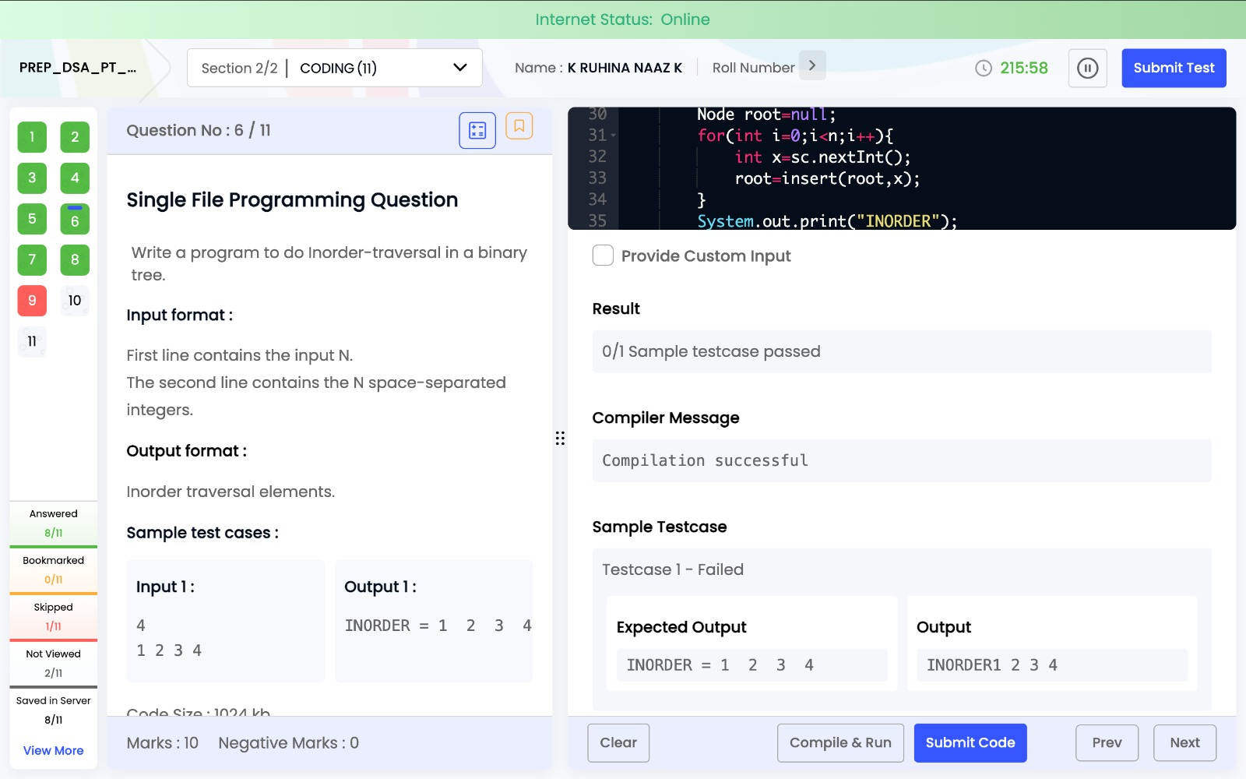

Program 7:
import java.util.*;

class Node {
int data;
Node left, right;

Node(int d) {
data = d;
left = right = null;
}
}

public class Main {

static Node insert(Node root, int data) {
if (root == null)
return new Node(data);

if (data < root.data)
root.left = insert(root.left, data);
else
root.right = insert(root.right, data);

return root;
}

static void postorder(Node root) {
if (root != null) {
postorder(root.left);
postorder(root.right);
System.out.print(root.data + " ");
}
}

public static void main(String[] args) {
Scanner sc = new Scanner(System.in);

int n = sc.nextInt();
Node root = null;

for (int i = 0; i < n; i++) {
int x = sc.nextInt();
root = insert(root, x);
}

System.out.print("POSTORDER ");
postorder(root);
}
}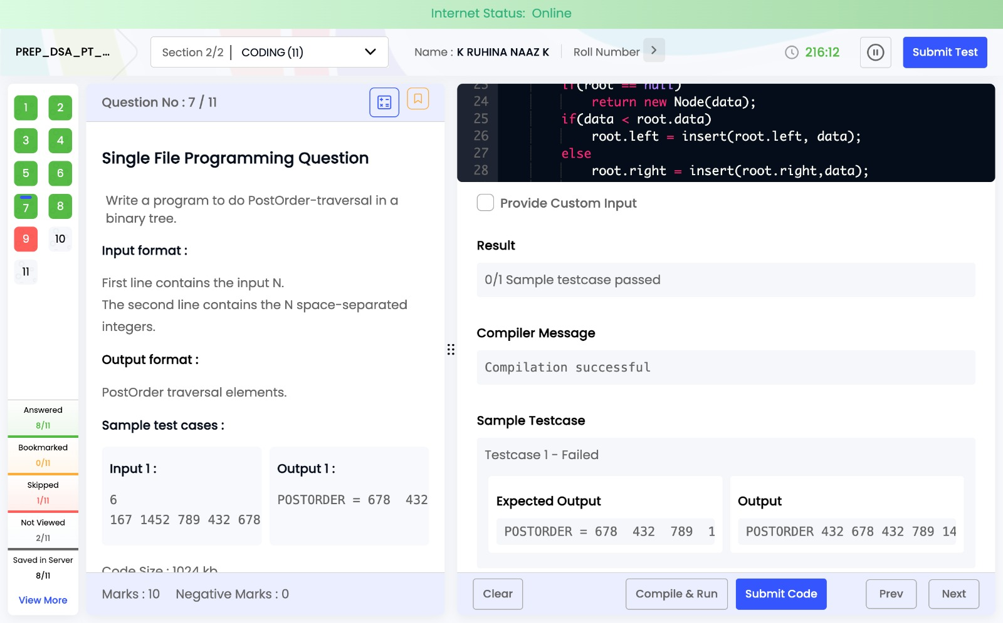

Program 8:
import java.util.*;

class Node {
int data;
Node left, right;

Node(int data) {
this.data = data;
left = right = null;
}
}

public class Main {

static Node insert(Node root, int data) {
if (root == null) {
return new Node(data);
}

if (data < root.data)
root.left = insert(root.left, data);
else
root.right = insert(root.right, data);

return root;
}

static void preorder(Node root) {
if (root != null) {
System.out.print(root.data + " ");
preorder(root.left);
preorder(root.right);
}
}

public static void main(String[] args) {
Scanner sc = new Scanner(System.in);
int n = sc.nextInt();
Node root = null;

for (int i = 0; i < n; i++) {
int x = sc.nextInt();
root = insert(root, x);
}

System.out.print("PREORDER = ");
preorder(root);
}
}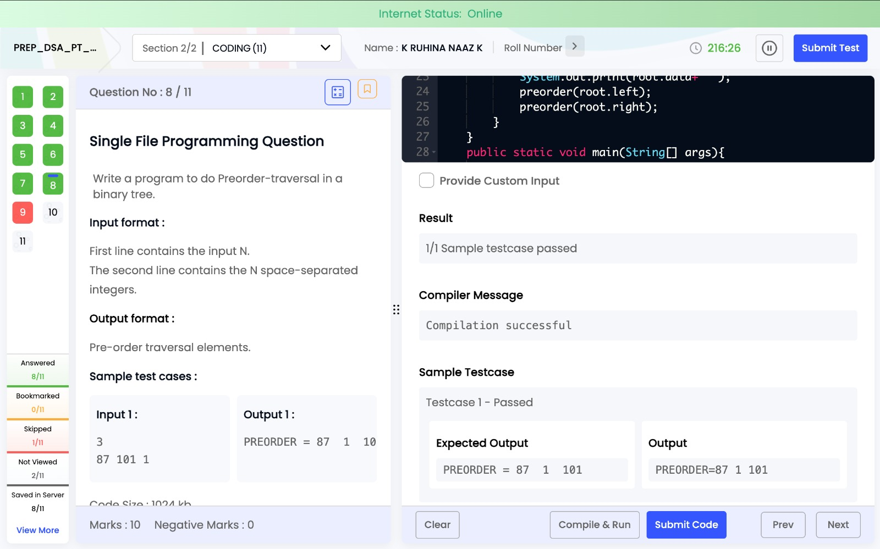

Program 9:
import java.util.*;

public class Main {
public static void main(String[] args) {
Scanner sc = new Scanner(System.in);

int sum = 0;

for(int i = 0; i < 7; i++) {
int num = sc.nextInt();
sum += num;
}

System.out.println(sum);
}
}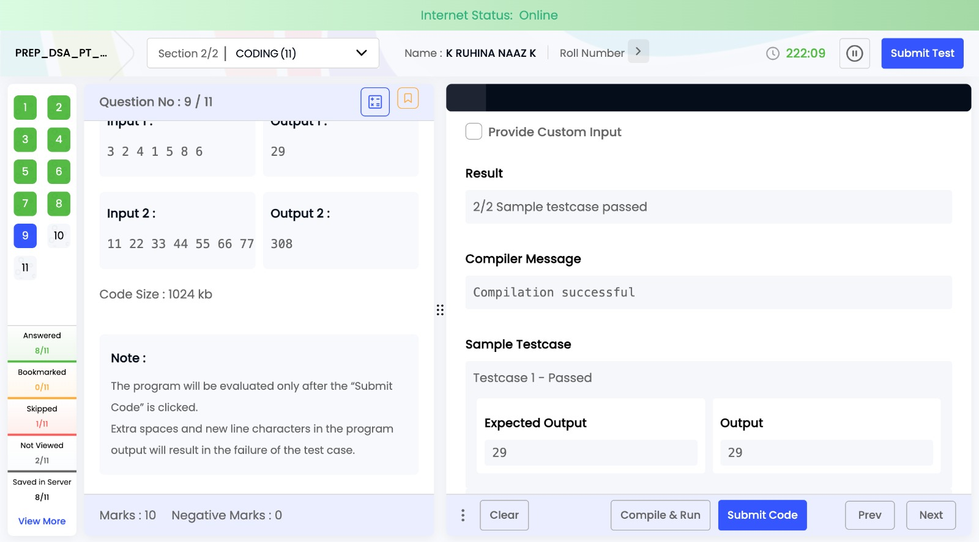

Program 10:
import java.util.*;

class Node {
int data;
Node left, right;

Node(int data) {
this.data = data;
left = right = null;
}
}

public class Main {

static void preorder(Node root) {
if (root != null) {
System.out.print(root.data + " ");
preorder(root.left);
preorder(root.right);
}
}

static void inorder(Node root) {
if (root != null) {
inorder(root.left);
System.out.print(root.data + " ");
inorder(root.right);
}
}

static void postorder(Node root) {
if (root != null) {
postorder(root.left);
postorder(root.right);
System.out.print(root.data + " ");
}
}

public static void main(String[] args) {
Scanner sc = new Scanner(System.in);

int a = sc.nextInt();
int b = sc.nextInt();
int c = sc.nextInt();
int d = sc.nextInt();
int e = sc.nextInt();

Node root = new Node(a);
root.left = new Node(b);
root.right = new Node(c);
root.left.left = new Node(d);
root.left.right = new Node(e);

System.out.println("Preorder traversal:");
preorder(root);

System.out.println("\nInorder traversal:");
inorder(root);

System.out.println("\nPostorder traversal:");
postorder(root);
}
}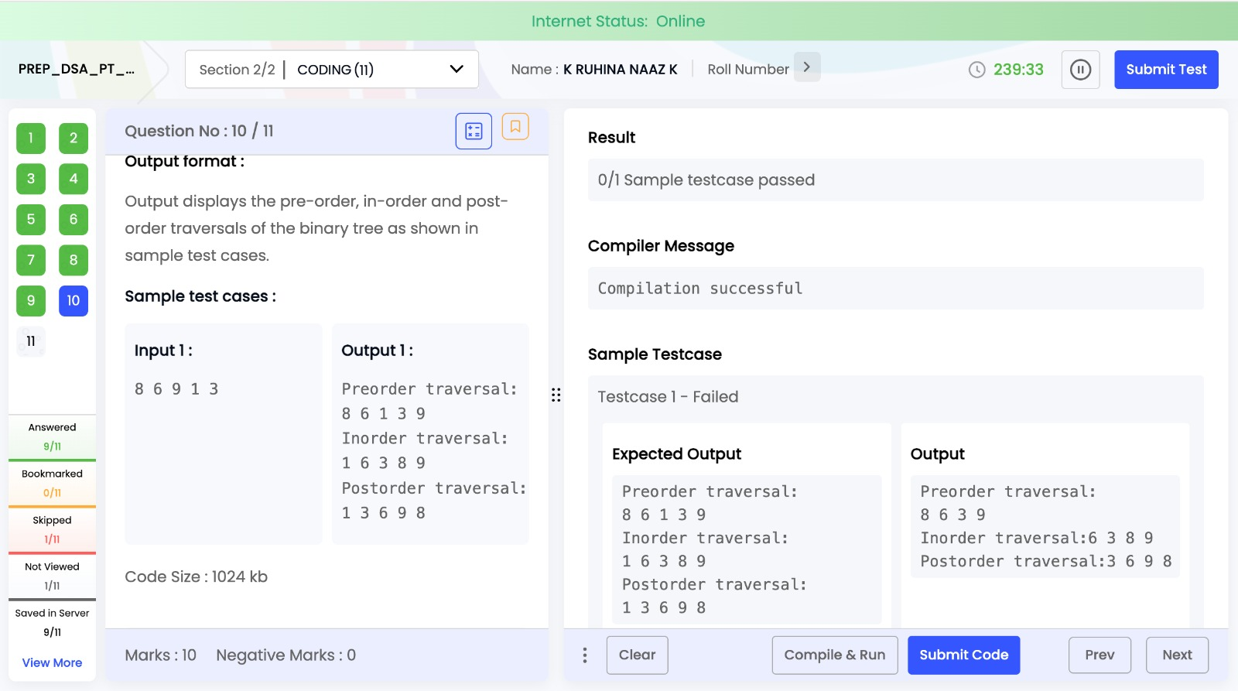

Program 11:
import java.util.*;

public class Main {
public static void main(String[] args) {
Scanner sc = new Scanner(System.in);

int n = 10;
int[] arr = new int[n];

for(int i = 0; i < n; i++) {
arr[i] = sc.nextInt();
}

boolean isHeap = true;

for(int i = 0; i < n; i++) {

int left = 2*i + 1;
int right = 2*i + 2;

if(left < n && arr[i] < arr[left]) {
isHeap = false;
break;
}

if(right < n && arr[i] < arr[right]) {
isHeap = false;
break;
}
}

if(isHeap)
System.out.println("Heap");
else
System.out.println("not a Heap");
}
}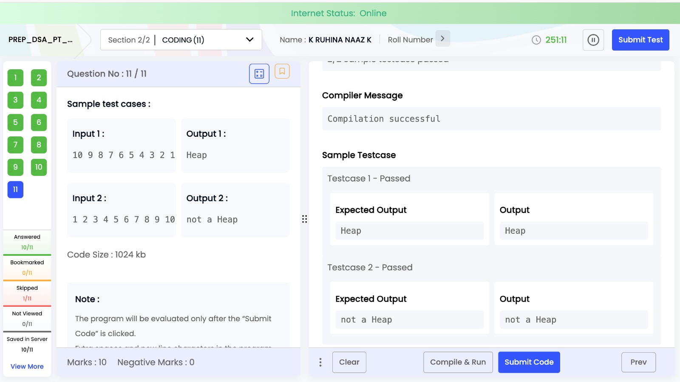

Task 4 : PREP_DSA_AS_Tree_1
Program 1:
import java.util.*;

class Node {
int data;
Node left, right;

Node(int data) {
this.data = data;
left = right = null;
}
}

public class Main {

static Node insert(Node root, int data) {
if (root == null)
return new Node(data);

if (data < root.data)
root.left = insert(root.left, data);
else
root.right = insert(root.right, data);

return root;
}

static void inorder(Node root) {
if (root != null) {
inorder(root.left);
System.out.print(root.data + " ");
inorder(root.right);
}
}

static void levelOrder(Node root) {
Queue<Node> q = new LinkedList<>();
q.add(root);

while (!q.isEmpty()) {
Node temp = q.poll();
System.out.print(temp.data + " ");

if (temp.left != null)
q.add(temp.left);

if (temp.right != null)
q.add(temp.right);
}
}

public static void main(String[] args) {
Scanner sc = new Scanner(System.in);

int n = sc.nextInt();
Node root = null;

for (int i = 0; i < n; i++) {
int x = sc.nextInt();
root = insert(root, x);
}

inorder(root);
System.out.println();
levelOrder(root);
}
}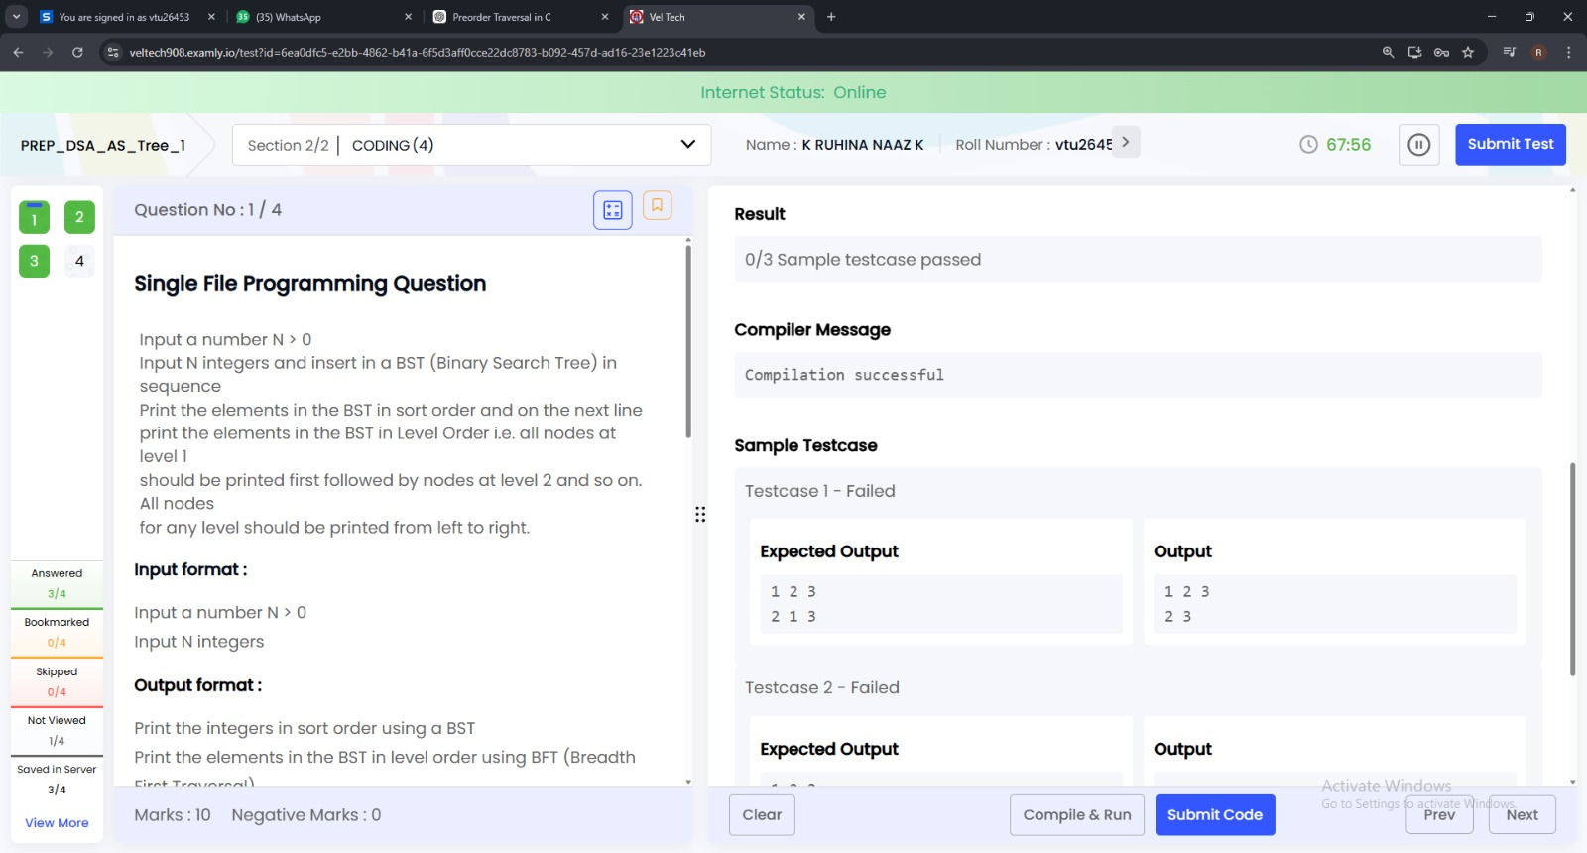

Program 2:
import java.util.*;

class Solution {

public static void heapify(int[] arr, int n, int i) {
int smallest = i;
int left = 2 * i + 1;
int right = 2 * i + 2;

if (left < n && arr[left] < arr[smallest])
smallest = left;

if (right < n && arr[right] < arr[smallest])
smallest = right;

if (smallest != i) {
int temp = arr[i];
arr[i] = arr[smallest];
arr[smallest] = temp;

heapify(arr, n, smallest);
}
}

public static void buildMinHeap(int[] arr, int n) {
for (int i = n / 2 - 1; i >= 0; i--) {
heapify(arr, n, i);
}
}

public static void main(String[] args) {
Scanner sc = new Scanner(System.in);

int n = sc.nextInt();
int[] arr = new int[n];

for (int i = 0; i < n; i++) {
arr[i] = sc.nextInt();
}

buildMinHeap(arr, n);

System.out.println("Min Heap");
for (int num : arr) {
System.out.println(num);
}
}
}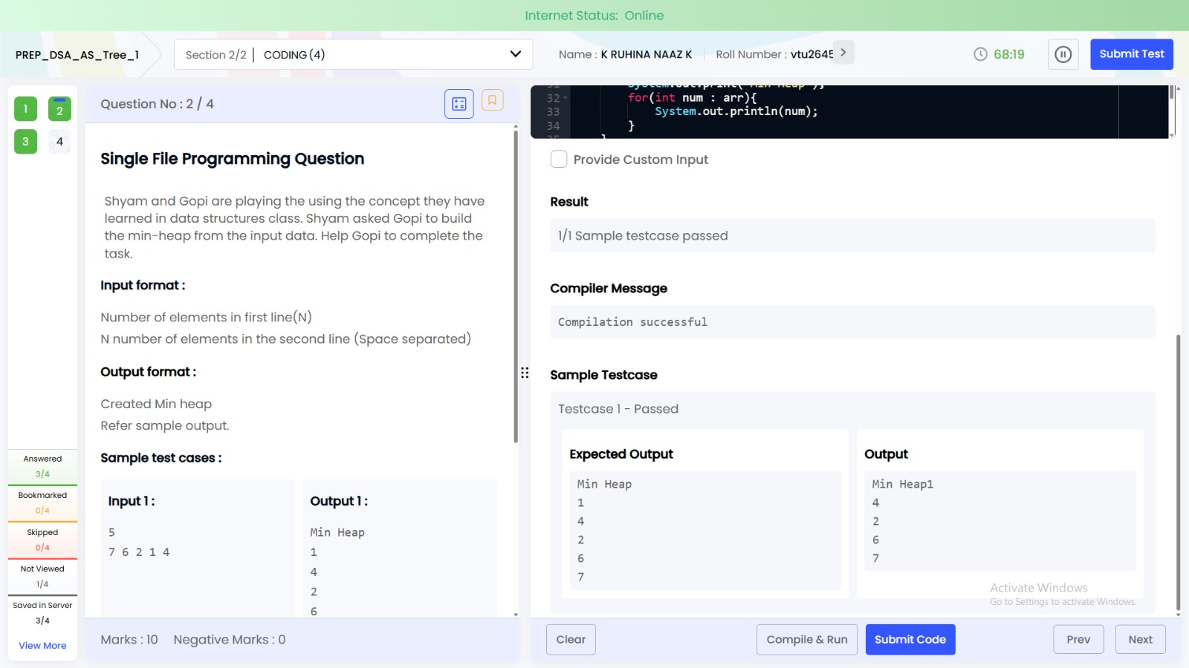

Program 3:
import java.util.*;

class Solution {
static class Node {
int data;
Node left, right;
Node(int d) { data = d; }
}

public static void main(String[] args) {
Scanner sc = new Scanner(System.in);

int[] arr = new int[7];
for (int i = 0; i < 7; i++) arr[i] = sc.nextInt();

// build tree
Node root = new Node(arr[0]);
Queue<Node> q = new LinkedList<>();
q.add(root);

int i = 1;
while (i < 7) {
Node cur = q.poll();
cur.left = new Node(arr[i++]);
q.add(cur.left);
if (i < 7) {
cur.right = new Node(arr[i++]);
q.add(cur.right);
}
}

// spiral traversal
boolean rev = false;
q.add(root);

while (!q.isEmpty()) {
int size = q.size();
List<Integer> temp = new ArrayList<>();

for (int j = 0; j < size; j++) {
Node n = q.poll();
temp.add(n.data);
if (n.left != null) q.add(n.left);
if (n.right != null) q.add(n.right);
}

if (rev) Collections.reverse(temp);

for (int val : temp) System.out.print(val + " ");

rev = !rev;
}
}
}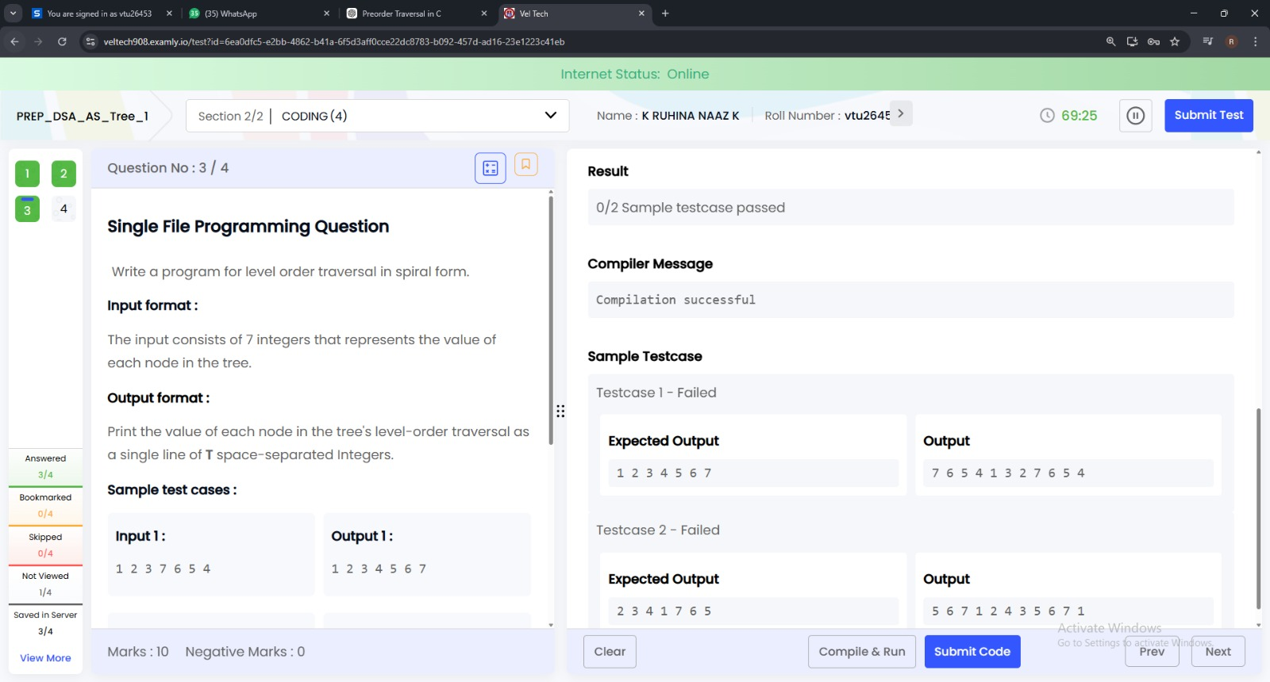

Program 4:
import java.util.*;

class Solution {
static class Node {
int data;
Node left, right;
Node(int d) { data = d; }
}

// insert into BST
static Node insert(Node root, int val) {
if (root == null) return new Node(val);
if (val < root.data) root.left = insert(root.left, val);
else root.right = insert(root.right, val);
return root;
}

// count leaf nodes
static int countLeaves(Node root) {
if (root == null) return 0;
if (root.left == null && root.right == null) return 1;
return countLeaves(root.left) + countLeaves(root.right);
}

public static void main(String[] args) {
Scanner sc = new Scanner(System.in);

int n = sc.nextInt();
Node root = null;

for (int i = 0; i < n; i++) {
root = insert(root, sc.nextInt());
}

System.out.println(countLeaves(root));
}
}